**Directions**: Follow the steps below to accomplish this task.

1. Create a new C# project with a name **045_lastname1_lastname2_F1db**.
2. Modify Form1 to implement CRUD for the **MODEL table only**. How to implement this is up to you.
3. When you insert, all fields are required for all fields except of course the IDs since it’s Auto Increment. A combo box should be used for the brand. The list of brands should be retrieved from the from **brand** table. Take note that since the **brandid** is a foreign in the **model table**, its value should depend on the **brandid** from the **brand table**.

Example:

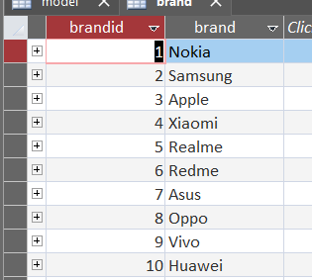Since the ID of Samsung is 2 in the **brand table**, this ID should be reflected int the model table if you insert a new record as shown in the figure below.

1. For the update, use the model_desc as your reference in the WHERE clause. The model_desc, price, and brand may be updated if necessary. A combo box should be used for the brand. The list of brands should be retrieved from the from **brand** table. Take note that since the **brandid** is a foreign in the **model table**, its value should depend on the **brandid** from the **brand table**.
2. When you delete, use the model_desc as your reference for the WHERE clause.
3. There should be 3 ways to search for a model. They are as follows:
   1. Using the model_desc as keyword.
   2. Using brand.
   3. Using price range.

**Note**: How you implement the price range is up to you.